DSCI5350 Spark Activity-3 Satyasriharsha Buddha

Uploading json file using spark SQL data frames  
1)Create Scala notebook and upload Singleline.json data. Copy the path of the uploaded data set

Path- dbfs:/FileStore/shared_uploads/sriharshabuddha@my.unt.edu/Singleline.json

2)Read the json file

3)Printing the schema

4) Save the file as temporary table

5)Select all data from temporary table and store it in a different variable

6)Display all the records

For Multiline.json

1. Create Scala notebook and upload multiline.json data. Copy the path of the uploaded data set

Path : dbfs:/FileStore/shared_uploads/sriharshabuddha@my.unt.edu/Multiline-1.json

2)Read the json file

3)Printing the schema

4) Save the file as temporary table



5)Select all data from temporary table and store it in a different variable

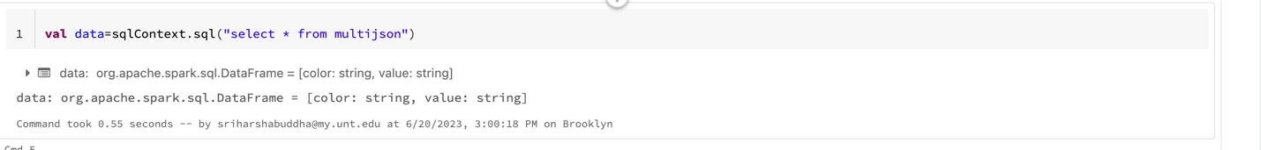

6)Display all the records

